FOR IMMEDIATE RELEASE
May 14, 2024

BLIPPI TO ROCK OUT IN AN ALL-NEW LIVE BAND SHOW
WITH A SPECIAL STOP IN FARGO
Global sensation Blippi to delight audiences at SCHEELS arena in Fargo, North Dakota in all-new live show, Blippi: Join the Band Tour, on November 21, 2024

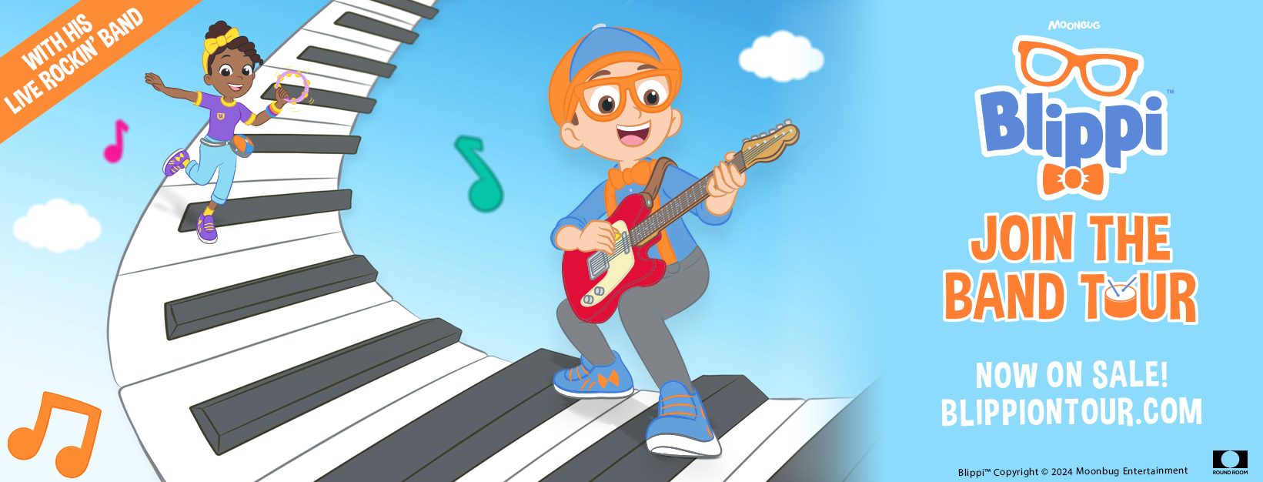

Tickets on sale Friday, May 17 via Ticketmaster

Tuesday, May 14, 2024 – Round Room Live and Moonbug Entertainment are proud to announce a new live show, Blippi: Join the Band Tour. The brand-new production features musicians playing LIVE on stage and promises to bring the vivacious, energetic, and educational antics of global sensation Blippi to stages across North America in a never-before-seen show, with a stop in Fargo on November 21.

Tickets for Blippi: Join the Band Tour will go on-sale this Friday, May 17th, with pre-sales beginning today (Tuesday, May 14th). For tickets and additional information, visit Ticketmaster.com.
Join Blippi to make music in your hometown in the brand new live Blippi: Join the Band Tour! Blippi will be joined onstage by Meekah along with their singing and dancing buddies and LIVE musicians. They’ll explore what makes music, including sounds, rhythms and instruments, with fan-favorite Blippi hits. So grab your drumsticks, tune up your guitar, and move those feet with Blippi and get ready for a musical performance that's fun for the whole family!

“We are turning it up to 11 with the Blippi: Join the Band Tour this Fall,” said Stephen Shaw, Founder and Co-President of Round Room Live. “Blippi is a rockstar for today’s kids and has been delighting millions of children and families all over the world. A brand new show that amps up the excitement to an even higher volume with a live band onstage was the next logical step in continuing Blippi touring around the world."

"Following the success of previous tours, Blippi: Join the Band Tour will bring families to their feet across the country to dance and sing along to their favorite Blippi hits as well as some brand new songs.” Susan Vargo, Head of Global Experiences at Moonbug Entertainment added, “Parents and kids alike will share in making music the Blippi way, with curiosity and silliness center stage!"

Blippi on Tour has traveled the globe multiple times and has delighted millions of international fans throughout North America, the United Kingdom, Mexico, Africa, Asia, and the Middle East, with plans to visit many more new countries in 2024.

Blippi inspires curiosity in preschoolers around the world by creating content and experiences that are relatable, accessible and make learning fun. Blippi has become a worldwide sensation with more than one billion monthly views across platforms including Netflix, HBO Max, Cartoonito, Sky, Amazon and YouTube, and millions of fans around the world. The franchise has expanded rapidly since it was acquired by Moonbug Entertainment in 2020. Blippi is available in more than 20 languages, including ASL, and is distributed by more than 30 global broadcast and streaming partners. Blippi’s buddies Meekah and Juca have spun off into their own shows and Blippi lives off the screen as well with sold-out live events, popular music tracks, and in-demand toys available at all major retailers.

For Blippi: Join the Band Tour, the characters Blippi and Meekah will be played by professional stage performers selected specifically for the tour.

Fans can visit BlippiOnTour.com now for tour dates and ticket information, and follow Blippi On Tour social media for exclusive tour content. A current list of tour dates can be found below and at BlippiOnTour.com.

FOLLOW BLIPPI ON TOUR
Official Website: www.BlippiOnTour.com
Facebook: @BlippiOnTour
Instagram: @BlippiOnTour
TikTok: @BlippiOnTour

FOLLOW BLIPPI
Official Website: www.Blippi.com
YouTube: @Blippi
Facebook: @Blippi
Twitter: @BlippiOfficial
Instagram: @BlippiOfficial

About Moonbug Entertainment
Moonbug is an award-winning global entertainment company inspiring kids everywhere to laugh, learn and grow. The company is behind some of the biggest kids’ entertainment brands in the world including CoComelon and Blippi. Moonbug believes every child should have access to entertaining and enriching content, making its shows available on more than 150 video platforms globally including Netflix, Disney+, BBC iPlayer and YouTube Kids. The company is also a global leader in pre-school music and audio experiences, available on 100+ audio platforms globally. Moonbug brands extend far beyond the screen to include streaming music, consumer products and live events.
Moonbug is part of Candle Media, an independent, creator-friendly home for cutting-edge, high-quality, category-defining brands and franchises. By bringing together elite talent operating at the intersection of content, community, and commerce, it helps to position leading entertainment businesses for accelerated, sustainable growth in the current market and beyond. Candle is run by its Co-Chairmen and Co-CEOs, leading entertainment executives Kevin Mayer and Tom Staggs, and backed by investment capital from funds managed by Blackstone’s flagship private equity business.

About Round Room Live:
Round Room Live is the leading producer and promoter of exhibitions and family show entertainment, specializing in transforming both new and iconic intellectual property into engaging and thrilling live events. Round Room creates unique live experiences tailored to the distinct character of each property and produces the highest quality productions for audiences around the world. Their current roster of touring theatrical shows includes: Blippi: The Wonderful World Tour, Blippi The Musical (2023 Olivier Award nomination for Best
Family production), Sesame Street Live!, Peppa Pig Live, Shrek the Musical (2024 US Tour), Nitro Circus 20th Anniversary Tour, and Blue’s Clues & You! Live On Stage. Round Room’s Immersive and Entertainment Experiences division is currently touring: Formula 1: The Exhibition, Jurassic World: The Exhibition, Mandela: The Official Exhibition, and Tupac Shakur. Wake Me When I’m Free.
####

For more information contact:

Tim Zick
tzick@scheelsarena.com

