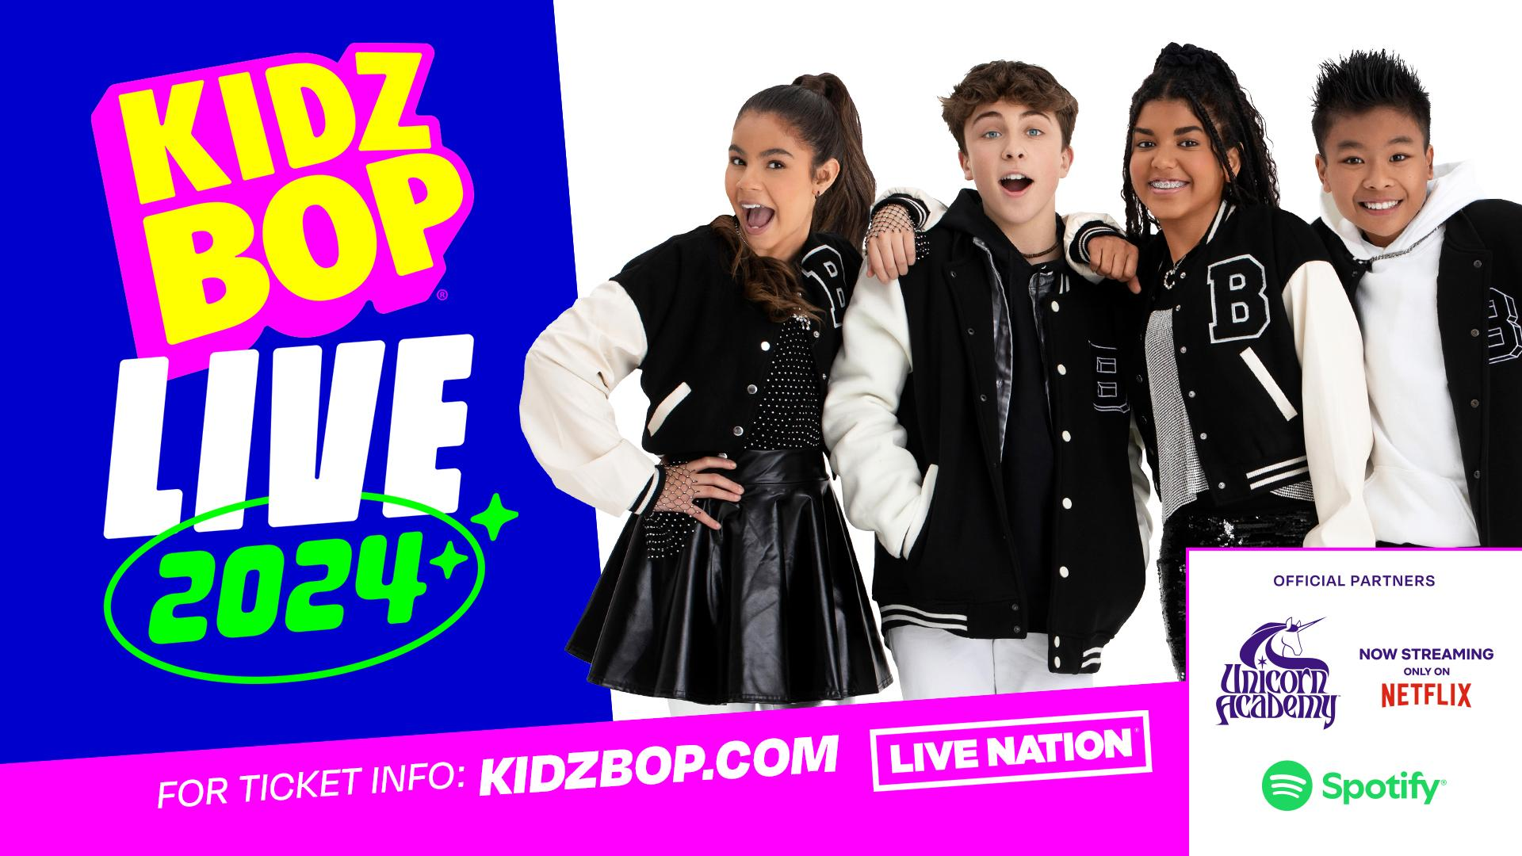

**KIDZ BOP Extends 2024 Tour; Adds 17 New Dates**

**Spotify Joins As An Official Tour Partner**

*Tour kicks off June 27 in Stamford, CT*

*Presales for new dates begin June 24; General on-sale begins June 28*

*Setlist includes hits from KIDZ BOP's newest album, 'KIDZ BOP 2024 Vol. 2,'*

*available for pre-order today*

**NEW YORK, June 21, 2024 -** [**KIDZ BOP**](https://kidzbop.com),the #1 music brand for kids, in partnership with Live Nation, is extending the *KIDZ BOP LIVE 2024* Tour through November, adding 17 new dates, including a show at the iconic Red Rocks Amphitheatre. [**Spotify**](https://open.spotify.com/) has also joined as an official tour partner, along with previously announced [**Spin Master’s Unicorn Academy™**](https://www.spinmaster.com/en-US/brands/unicorn-academy/)**.** Presales for the new dates begin Monday, June 24 and general on sale begins Friday, June 28. For all tour dates and ticket information, visit [**KIDZBOP.com/tour**](https://c212.net/c/link/?t=0&l=en&o=3965878-1&h=2164382623&u=http%3A%2F%2Fwww.kidzbop.com%2Ftour&a=KIDZBOP.com%2Ftour).

The tour kicks off on June 27 in Stamford, CT, and will hit 60+ cities including Atlanta, Baltimore, Boston, Dallas, Denver, New York, and more. The KIDZ BOP Kids will bring the ultimate pop concert for kids to hundreds of thousands of fans, where they’ll be performing the biggest bops of the year, including “Espresso,” “greedy,” “Lil Boo Thang,” “Million Dollar Baby,” “TEXAS HOLD ‘EM,” and more. Concert attendees will be the first to see brand-new choreography to songs from KIDZ BOP’s newest album [‘KIDZ BOP 2024 Vol. 2.'](https://link.kidzbop.com/KIDZBOP2024vol2) - out globally on July 12 and available for digital pre-order today.

*KIDZ BOP LIVE 2024* is teaming up with Spotify, the world’s most popular audio streaming subscription service, and Spin Master’s new fantasy-adventure children’s series, Unicorn Academy™. In select cities, Spotify will host interactive back-to-school activations for families to enjoy. Fans can listen to their favorite KIDZ BOP tracks with the "[KIDZ BOP Party](https://open.spotify.com/playlist/37i9dQZF1DWZGe3coPVOS4?si=35db4d7e512744d0)" playlist on Spotify. Spin Master’s Unicorn Academy™ will promote the second season of the series, which is available to stream on Netflix June 27. Fans will enjoy a co-branded music video that will play before each concert, along with pop-up activations in select cities, where kids can transform into their favorite Unicorn Academy™ characters, interact with show content and toys, and more.

**PRESALES:** Citi is the official card of the *KIDZ BOP LIVE 2024* Tour. Citi cardmembers will have access to presale tickets beginning Monday, June 24 at 10am local time until Thursday, June 27 at 10pm local time through the Citi Entertainment program. For complete presale details visit [www.citientertainment.com](https://c212.net/c/link/?t=0&l=en&o=3761990-1&h=2149768079&u=http%3A%2F%2Fwww.citientertainment.com%2F&a=www.citientertainment.com). Additional fan presales will run throughout the week, including offers for past KIDZ BOP ticket purchasers, and a Spotify Fans First presale, where top fans will receive an email with first access to tickets.

**VIP:** KIDZ BOP VIP Packages are the perfect way to amp up your concert experience. Four different KIDZ BOP VIP Packages are available on [VIPNation.com](https://www.vipnation.com/tour/kidz-bop-live-2024), which include premium tickets, exclusive merchandise, a pre-show dance party and a post-show Meet & Greet with the KIDZ BOP Kids, and a group party experience - perfect for any celebration!

KIDZ BOP partnered with Red Light Management, the largest independent management company in the world, to represent the KIDZ BOP tour. Independent Artist Group (IAG) is also representing the KIDZ BOP tour.

***KIDZ BOP LIVE 2024 TOUR - PREVIOUSLY ANNOUNCED***

| **DATE** | **LOCATION** | **VENUE** |
| --- | --- | --- |
| June 27, 2024 | Stamford, CT* | Palace Theatre |
| June 28, 2024 | Stamford, CT* | Palace Theatre |
| July 3, 2024 | Gilford, NH | BankNH Pavilion |
| July 5, 2024 | Noblesville, IN | Ruoff Music Center |
| July 6, 2024 | Clarkston, MI | Pine Knob Music Theatre |
| July 7, 2024 | Buffalo, NY | Darien Lake Amphitheater |
| July 12, 2024 | Raleigh, NC | Coastal Credit Union Music Park at Walnut Creek |
| July 13, 2024 | Camden, NJ | Freedom Mortgage Pavilion |
| July 14, 2024 | Bethel, NY | Bethel Woods Center for the Arts |
| July 19, 2024 | Rogers, AR | Walmart AMP |
| July 20, 2024 | Kansas City, MO | Starlight Theatre |
| July 21, 2024 | Saint Louis, MO | Hollywood Casino Amphitheatre |
| July 24, 2024 | Columbus, OH* | Ohio State Fair |
| July 26, 2024 | Saratoga Springs, NY | Broadview Stage at SPAC |
| July 27, 2024 | Boston, MA (2 Shows) | Leader Bank Pavilion |
| July 28, 2024 | Bangor, ME | Maine Savings Amphitheater |
| August 2, 2024 | Virginia Beach, VA | Veterans United Home Loans Amphitheater |
| August 3, 2024 | Wantagh, NY | Northwell Health at Jones Beach Theater |
| August 4, 2024 | Hershey, PA | GIANT Center |
| August 6, 2024 | West Allis, WI* | Wisconsin State Fair |
| August 9, 2024 | Holmdel, NJ | PNC Bank Arts Center |
| August 10, 2024 | Vienna, VA (2 Shows)* | Wolf Trap at Filene Center |
| August 11, 2024 | Cuyahoga Falls, OH | Blossom Music Center |
| August 16, 2024 | Burgettstown, PA | The Pavilion at Star Lake |
| August 17, 2024 | Tinley Park, IL | Credit Union 1 Amphitheatre |
| August 18, 2024 | Des Moines, IA* | Iowa State Fair |
| August 23, 2024 | Toronto, ON | Budweiser Stage |
| August 24, 2024 | Syracuse, NY* | New York State Fair |
| August 25, 2024 | Holmdel, NJ | PNC Bank Arts Center |
| August 30, 2024 | Franklin, TN | FirstBank Amphitheater |
| August 31, 2024 | Cincinnati, OH | Riverbend Music Center |
| September 2, 2024 | St. Paul, MN* | Minnesota State Fair |
| September 6, 2024 | Phoenix, AZ | Arizona Financial Theatre |
| September 7, 2024 | San Diego, CA | Cal Coast Credit Union Open Air Theatre |
| September 8, 2024 | Inglewood, CA | YouTube Theater |
| September 11, 2024 | Puyallup, WA* | Washington State Fair |
| September 14, 2024 | Pocatello, ID* | Portneuf Health Trust Amphitheater |
| September 20, 2024 | Bend, OR | Hayden Homes Amphitheater |
| September 21, 2024 | Wheatland, CA | Toyota Amphitheatre |
| September 22, 2024 | Mountain View, CA | Shoreline Amphitheatre |
| September 27, 2024 | Austin, TX | Germania Insurance Amphitheater |
| September 28, 2024 | Woodlands, TX | The Cynthia Woods Mitchell Pavilion |
| September 29, 2024 | Irving, TX | The Pavilion at Toyota Music Factory |
| October 4, 2024 | West Palm Beach, FL | iTHINK Financial Amphitheatre |
| October 5, 2024 | Tampa, FL | MIDFLORIDA Credit Union Amphitheatre |
| October 6, 2024 | Alpharetta, GA | Ameris Bank Amphitheatre |

***KIDZ BOP LIVE 2024 TOUR - NEW DATES ADDED***

| **DATE** | **LOCATION** | **VENUE** |
| --- | --- | --- |
| October 11, 2024 | Baltimore, MD | Pier Six Pavilion |
| October 12, 2024 | Toledo, OH | Stranahan Theater |
| October 13, 2024 | Louisville, KY | The Louisville Palace |
| October 18, 2024 | Tulsa, OK | Tulsa Theater |
| October 19, 2024 | Southaven, MS | BankPlus Amphitheater at Snowden Grove |
| October 20, 2024 | Brandon, MS | Brandon Amphitheater |
| October 25, 2024 | El Paso, TX | Abraham Chavez Theatre |
| October 26, 2024 | Albuquerque, NM | Isleta Amphitheater |
| October 27, 2024 | Denver, CO | Red Rocks Amphitheatre |
| November 1, 2024 | Omaha, NE | Orpheum Theater Omaha |
| November 2, 2024 | Sioux Falls, SD | Sioux Falls Arena |
| November 3, 2024 | Fargo, ND* | Scheels Arena |
| November 8, 2024 | Knoxville, TN | Tennessee Theatre |
| November 9, 2024 | Chattanooga, TN | Soldiers and Sailors Memorial Auditorium |
| November 10, 2024 | North Charleston, SC | North Charleston Performing Arts Center |
| November 15, 2024 | Wallingford, CT | Toyota Oakdale Theatre |
| November 16, 2024 | Utica, NY | The Stanley Theatre |

* Non-Live Nation Dates

For a full list of tour dates and ticket information, visit[KIDZBOP.com/Tour](http://kidzbop.com/Tour)[.](http://www.kidzbop.com/tour)

**About KIDZ BOP**

KIDZ BOP is the #1 music brand for kids, featuring today’s biggest global pop hits, “sung by kids for kids.” Since its launch, the family-friendly music brand has sold more than 24 million albums and generated over 11 billion streams. KIDZ BOP connects with kids and families through its best-selling albums, music videos, consumer products and live tours. The music franchise is expanding internationally and currently records in 5 different languages. KIDZ BOP is Billboard Magazine’s “#1 Kid Artist” for eleven years. The brand has its own dedicated channel on SiriusXM – KIDZ BOP Radio (Channel 135) — where it’s all KIDZ BOP, all the time. KIDZ BOP has had 24 Top 10 debuts on the Billboard 200 Chart; only three artists in history—The Beatles, The Rolling Stones, and Barbra Streisand—have had more Top 10 albums. For more information, visit [**www.KIDZBOP.com**](http://www.kidzbop.com/)**.** KIDZ BOP is a part of Concord.

**About Live Nation Entertainment**Live Nation Entertainment (NYSE: [LYV](https://www.prnewswire.com/news-releases/kidz-bop-and-live-nation-announce-all-new-2023-tour-301726482.html#financial-modal)) is the world's leading live entertainment company composed of global market leaders: Ticketmaster, Live Nation Concerts, and Live Nation Sponsorship. For additional information, visit [**www.livenationentertainment.com**](http://www.livenationentertainment.com).

**About Spotify**

Spotify’s mission is to unlock the potential of human creativity by giving a million creative artists the opportunity to live off their art and billions of fans the opportunity to enjoy and be inspired by it. Spotify’s platform revolutionized music listening forever when we launched in 2008. Our move into podcasting brought innovation and a new generation of listeners to the medium, and in 2022 we entered the next audio market primed for growth with the addition of audiobooks. Today, more listeners than ever can discover, manage and enjoy over 100 million tracks, five million podcast titles, and 250,000 audiobooks on Spotify. We are the world’s most popular audio streaming subscription service with more than 615 million users, including 239 million subscribers in more than 180 markets. We use our Investors and For the Record websites as well as other social media listed in the “Resources – Social Media” tab of our Investors website to disclose material company information. For more information, images, or to contact the press team, head over to https://newsroom.spotify.com/.

**About Spin Master**

Spin Master Corp. (TSX:TOY) is a leading global children's entertainment company, creating exceptional play experiences through its three creative centres: Toys, Entertainment and Digital Games. With distribution in over 100 countries, Spin Master is best known for award-winning brands PAW Patrol®, Hatchimals®, Bakugan®, Kinetic Sand®, Air Hogs®, Melissa & Doug®, Rubik's® Cube and GUND®, and is the global toy licensee for other popular properties. Spin Master Entertainment creates and produces compelling multiplatform content, through its in-house studio and partnerships with outside creators, including the preschool franchise *PAW Patrol,* and numerous other original shows, short-form series and feature films. The Company has an established presence in digital games, anchored by the Toca Boca® and Sago Mini® brands, offering open-ended and creative game and educational play in digital environments. Through Spin Master Ventures, the Company makes minority investments globally in emerging companies and start-ups. With 31 offices spanning nearly 20 countries, Spin Master employs close to 3,000 team members globally. For more information visit [**spinmaster.com**](https://c212.net/c/link/?t=0&l=en&o=4072151-1&h=1049127731&u=https%3A%2F%2Fwww.spinmaster.com%2F&a=spinmaster.com) or follow-on Instagram, Facebook and Twitter @spinmaster.