**FOR RELEASE (June 4, 2024)**

**Global Icon Paula Abdul set to perform at SCHEELS arena in Fargo this October**

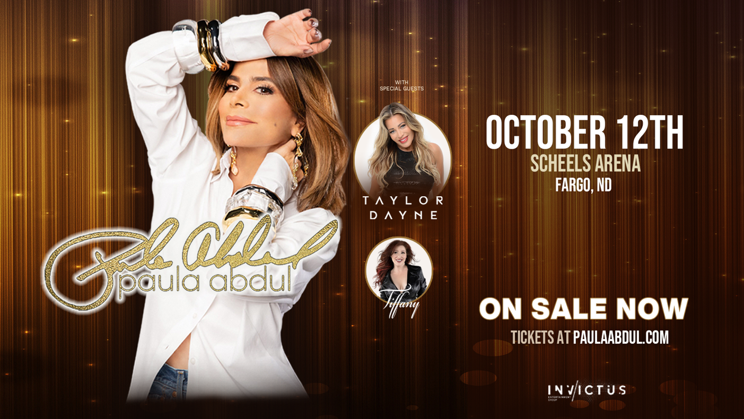

**(June 4, 2024) – Fargo, ND –** Global icon Paula Abdul announces show October 12th at SCHEELS arena in Fargo, ND.  
  
A music superstar, dancer, renowned choreographer, and TV personality - this event is an event not to be missed. Tickets go on sale **Friday, June 7th at 10AM CST.**

With 60 million records sold, she has earned numerous awards and recognitions including 17 MTV Video Music Awards nominations with 5 wins, 2 GRAMMY Awards, 3 AMAs, 2 Emmy Awards, two People’s Choice Awards, and five Juno Awards.

She began as a Laker girl at 18, becoming the head choreographer for the renowned squad. Many superstars sought her expertise -- Janet Jackson, Michael Jackson, Dolly Parton, to name a few.  She also choreographed numerous films and TV shows including “Coming to America,” “Jerry Maguire,” and “The Doors.”

Paula’s first studio album, Forever Your Girl, sold over 7 million copies in the U.S. alone and, with 4 singles topping the charts, “Forever Your Girl”, “Cold Hearted”, “Opposites Attract”, and of course, “Straight Up,” she set a record for the most #1 Billboard charted singles from a debut album.

After several national tours, Paula enjoyed her Paula Abdul: Forever Your Girl Las Vegas residency in 2019.

She has received the Ellis Island Medal of Honor in 2019, the Harry Chapin Memorial Humanitarian Award, and a star on the Hollywood Walk of Fame. Paula is an active philanthropist on behalf of many charities including Wigs & Wishes, Children's Hospital LA, No Kid Hungry, American Humane Association, and Dancers Against Cancer, to name a few.

**Paula Abdul – Live In Concert – October 12 at SCHEELS arena**

**Tickets on sale Friday, June 7th via Ticketmaster.com**

Paulaabdul.com

Facebook, Twitter + Instagram: @paulaabdul

**Venue and Promoter Contacts:**

*Tim Zick | Marketing Manager – SCHEELS arena – tzick@scheelsarena.com*

*David Langley | Director of Marketing – Invictus –* [*david@iegroup.ca*](mailto:david@iegroup.ca)

**